**CHANDIGARH UNIVERSITY**

UNIVERSITY INSTITUTE OF ENGINEERING

**DEPARTMENT OF COMPUTER SCIENCE & ENGINEERING**



|  |  |
| --- | --- |
| **Submitted By:                                                                          Submitted To:**  Yash Gupta Monika(E12802) | |
| **Subject Name** | Design Analysis and Algorithm |
| **Subject Code** | 20CSP_312 |
| **Branch** | CSE |
| **Semester** | 5th |

**LAB -INDEX**

|  |  |  |  |  |  |  |  |
| --- | --- | --- | --- | --- | --- | --- | --- |
| **Sr.No** | **Program** | **Date** | **Evaluation** | | | | **Sign** |
| **LW(12)** | **VV(8)** | **FW(10)** | **Total (30)** |
|  |  |  |  |  |  |  |  |
|  |  |  |  |  |  |  |  |
|  |  |  |  |  |  |  |  |
|  |  |  |  |  |  |  |  |
|  |  |  |  |  |  |  |  |
|  |  |  |  |  |  |  |  |
|  |  |  |  |  |  |  |  |
|  |  |  |  |  |  |  |  |
|  |  |  |  |  |  |  |  |
|  |  |  |  |  |  |  |  |

**Experiment 3**

**1. Aim/Overview of the practical:**

***Counting frequencies of array elements.***

**2. Algorithm:**

Step 1: Let us make an array of size n taken by user.

Step 2: Put the values in it.

Step 3: Make a variable freq=1 and idx=1 and element=arr[0].

Step 4: Now run a while loop to compare arr[idx-1] with arr[idx] if they are equal then increment of freq and ldx by 1 is there else print frequency of the element.

Step 5: Run the while loop till idx<n.

**3. Steps for experiment/practical/Code:**

#include <bits/stdc++.h>

using namespace std;

void countFreq(int arr[], int n)

{

unordered_map<int, int> mp;

for (int i = 0; i < n; i++)

mp[arr[i]]++;

for (auto x : mp)

cout << x.first << " " << x.second << endl;

}

int main()

{

int arr[] = { 10, 20, 20, 10, 10, 20, 5, 20 };

int n = sizeof(arr) / sizeof(arr[0]);

countFreq(arr, n);

return 0;

}

**4. Result/Output/Writing Summary:**

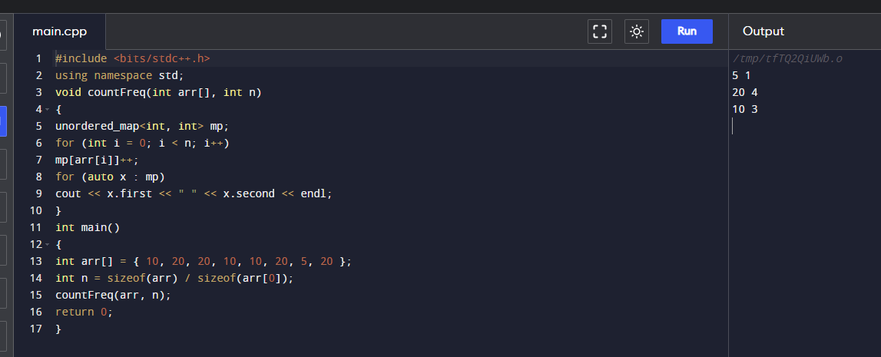

**5. Observations/Discussions/ Complexity Analysis:**

Time complexity of finding frequency of elements of an array is O(n).

**6. Learning outcomes (What I have learnt):**

**1.** To learn how to calculate the frequency of the elements of an array.

**2.** To learn how to use for loop in these cases.

**Evaluation Grid (To be created as per the SOP and Assessment guidelines by the faculty):**

|  |  |  |  |
| --- | --- | --- | --- |
| Sr. No. | Parameters | Marks Obtained | Maximum Marks |
| 1. |  |  |  |
| 2. |  |  |  |
| 3. |  |  |  |
|  |  |  |  |